PROJECT DOCUMENTATION

**HIGHLIGHT REPORT**

|  |  |
| --- | --- |
| **Project:** | **Business Management System for Lanka Tools (Pvt) Ltd** |
| Release: | August 2022 |
| Date: | 13th August 2022 |
| Period Covered: | 06/27/2022 - 08/12/2022 |
|  |  |
| **PRINCE2** |  |
|  |  |
| Author: | Bhathiya Kannangara, Ruwanthi Narampanawa |
| Owner: | Dr Yasas Jayaweera (Project Executive) |
| Client: | Lanka Tools by H.F.Athaf |
| Document Ref: | HiglightReport01_SmartBMS |
| Version No: | 1.0 |

# 1 Highlight Report History

## 1.1 Document Location

This document is only valid on the day it was printed.

The source of the document will be found on the project's PC in location

## 1.2 Revision History

**Date of this revision:** 08/12/2022

**Date of Next revision:**

|  |  |  |  |
| --- | --- | --- | --- |
| **Revision date** | **Previous revision date** | **Summary of Changes** | **Changes marked** |
| 08/12/2022 |  | First issue |  |

## 1.3 Approvals

This document requires the following approvals.

Signed approval forms are filed in the Management section of the project files.

|  |  |  |  |  |
| --- | --- | --- | --- | --- |
| **Name** | **Signature** | **Title** | **Date of Issue** | **Version** |
| Dr.Yasas Jayaweera |  | Project Executive | 08/12/2022 | 1.0 |
| Bhathiya Kannangara |  | Project Manager | 08/12/2022 | 1.0 |
| H.F Athaf |  | Client | 08/12/2022 | 1.0 |

## 1.4 Distribution

This document has been distributed to:

|  |  |  |  |
| --- | --- | --- | --- |
| **Name** | **Title** | **Date of Issue** | **Version** |
| Bhathiya Kannangara | Project Manager | 08/12/2022 | 1.0 |
| Imanka Jayasiriwardena | Startup Manager | 08/12/2022 | 1.0 |
| Layan Perera | Quality Manager | 08/12/2022 | 1.0 |
| R.A.G.U.T.Rajapaksha | Risk Manager | 08/12/2022 | 1.0 |
| Ruwanthi Narampanawa | Scheduling Manager | 08/12/2022 | 1.0 |

# 2 Table of Contents

1 Highlight Report History 2

1.1 Document Location 2

1.2 Revision History 2

1.3 Approvals 2

1.4 Distribution 2

2 Table of Contents 3

Highlight Report 4

3 Purpose 4

4 Budget Status 4

5 Schedule Status 5

6 Products Completed 6

7 Problems and Risk Update 7

8 Products to be completed 7

9 Project Issue Status 7

10 Budget/Schedule Impact 7

**List of Figures**

Figure 1: Scheduled Vs Completed (Week 01) 5

Figure 2: Scheduled Vs Completed (Week 02) 5

Figure 3: Scheduled Vs Completed 01 (Week 03) 5

Figure 4: Scheduled Vs Completed 02 (Week 03) 5

Figure 5: Scheduled Vs Completed (Week 04 & 05) 5

Figure 6: Scheduled Vs Completed (Week 05& 06) 6

# Highlight Report

## 3 Purpose

The goal of this highlight report is to provide an update on the progress of the Lanka Tools Business Management System. By the date indicated in this document, the development team had completed and turned in all necessary documents. Work was finished under the direction of Dr. Yasas Jayaweera, a project board member. Additionally, the foundation of Lanka Tools Business Management System is currently being built by the development team.

## 4 Budget Status

The following table demonstrate the current budget status of the Lanka Tools BMS.

As of the end of Sprint 01 team spent around 8% from the initial budget for hosting purchase and configurations.

|  |  |  |  |  |  |  |  |  |
| --- | --- | --- | --- | --- | --- | --- | --- | --- |
|  | | | **Estimated** | | | **Actual/Current** | | |
| Expense | Description | Basics | Unit | Rate | Total | Unit | Rate | Total |
| Set up configuration charges | | | | | |  |  |  |
| **Domain Purchasing** | Domain Registration | Per Year | 1 | 4000 | 4000 | 1 | 4000 | 4000 |
| **Web Hosting** | Purchase shared hosting to host Application and DB | Per Year | 1 | 15000 | 15000 | 1 | 15000 | 15000 |
| Project Planning | | | | | | | | |
| **Gather Requirements** | Gather details regarding the existing system/Business Processes and the requirements for the new system | Hourly | 12 | 500 | 6000 | 12 | 500 | 6000 |
| **Other Expenses** | Internet charges/Printouts Other | Hourly | 1 | 8000 | 8000 | 1 | 8000 | 8000 |
| Development | | | | | | | | |
| **Create Wireframes (Front end)** | Sketch and finalize the User Interfaces | Hourly | 9 | 1200 | 10800 | 9 | 1200 | 10800 |
| **Design back end** | Design the backend workflow | Hourly | 7 | 1500 | 10500 | 7 | 1500 | 10500 |
| **Frontend Implementation** | Developing the wireframes into final user interfaces. | Hourly | 35 | 1500 | 52500 | 35 | 1500 | 52500 |
| **Backend Implementation** | Implementing/Creating Backend functionalities | Hourly | 48 | 1500 | 72000 | 48 | 1500 | 72000 |
| **Design /Create and Implement the Database** | Develop a proper and secure database for the project | Hourly | 18 | 1500 | 27000 | 18 | 1500 | 27000 |
| Testing | | | | | | | | |
| **Unit Testing** | Test each and every part specifically when finished. | Hourly | 5 | 1000 | 5000 | - | - | - |
| **Final testing** | Perform the final testing of the whole developed system | Hourly | 8 | 1000 | 8000 | - | - | - |
| Setup of the System | | | | | |  |  |  |
| **Multiple API Usage** | Using of separate APIs to perform tasks | No of APIs | 3 | 3000 | 9000 | 3 | 3000 | 9000 |

## 5 Schedule Status

The team completed all tasks scheduled up to August 12th, 2022. The phases of system planning, requirement gathering, and proposed project design and development have all commenced successfully. The developers are actively participating in the development to complete the project.

1. Week 01 - Project Initiation

2. Week 02 - Time, cost planning and feasibility analysis

3. Week 03 – Requirement finalizing and Design

4. Week 04 & 05 - Sprint 01

5. Week 05 & 06 - Sprint 02

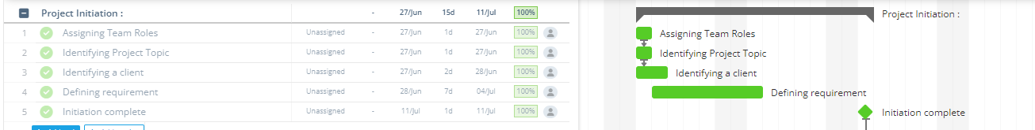

Figure 1: Scheduled Vs Completed (Week 01)

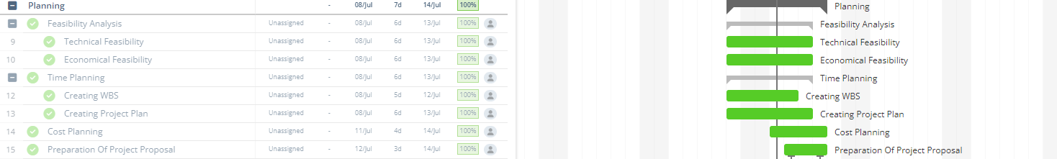

Figure 2: Scheduled Vs Completed (Week 02)



Figure 3: Scheduled Vs Completed 01 (Week 03)



Figure 4: Scheduled Vs Completed 02 (Week 03)

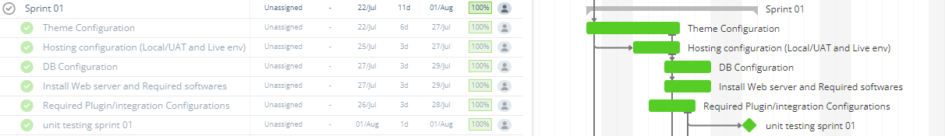

Figure 5: Scheduled Vs Completed (Week 04 & 05)



Figure 6: Scheduled Vs Completed (Week 05& 06)

## 6 Products Completed

According to the Lanka Tools Business Management System's product breakdown structure, the following products have been completed. The essential plugins have been installed, and GUI work will begin on August 14th, 2022, according to Gantt.

Lanka Tools BMS

* Purchased a web hosting for the project.
* Configured the webserver and PHP.
* DB design and configuration.
* Interface Design and development.
* Plugins and Integration configuration.
* Back end development and integration.

Documents

* Meeting minutes
* PFD
* PBS
* WBS
* Use Case Diagram
* Class Diagram
* Activity Diagrams
* ER Diagram
* Lanka Tools’s Software Requirement Specification Document (SRS)
* Project Brief
* Stage plan
* Work Packages
* Project Business Case
* Project plan
* Product description
* Project Initiation Document
* Communication Plan
* Configuration Management Plan
* Project Quality Plan
* Quality checklist
* Quality log
* Risk log
* Risk plan
* Gantt

## 7 Problems and Risk Update

The team has completed tasks without any main issues up to the expected level. It thus covers the completion of documents, and the team has not experienced any problems. Future concerns are predicted under the risk log and mitigated successfully.

## 8 Products to be completed

Lanka Tools BMS

* Component finalization and Integration
* Make necessary Modifications and Enhancements

Documents

* Lesson Learned Document
* User Acceptance Testing Document
* UAT Signoff Documents
* Lesson Learned Log
* Work Package
* Stage Plan
* Issue Log
* Project Approach
* User Documentation

## 9 Project Issue Status

Requests for changes/improvements/suggestions are discussed at the client meeting. Doubts frequently arise when using the PRINCE2 method to generate papers; as a result, members resolved their concerns at each board meeting by asking questions of the project board.

## 10 Budget/Schedule Impact

Up to this point, the implementation of the LANKATOOLS BMS progressing smoothly. The project team sticks to the estimated budget. Around 10% of the budgeted funds have was already been spent on the project's early duties. Hosting charges increased slight due to rupee depreciation. The original Gantt chart is being used to handle all of the jobs. The project manager has previously delegated project responsibilities to the team members. PM keeps track of each job assigned to team members using the Jira. As indicated in the Gantt chart, the team members want to complete the BMS on time because the project's timeline is critical. In addition, the team made no changes to the project's original budget or schedule.

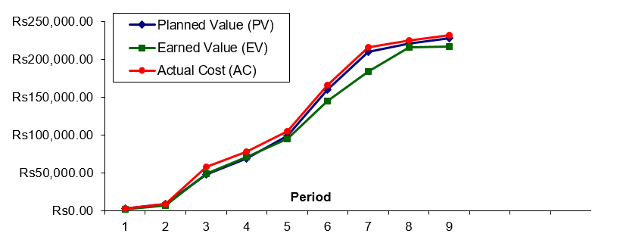

Figure 7: EV Analysis Graph

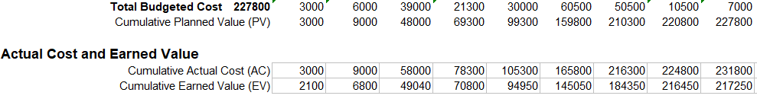

Figure 8: Summary of EV Analysis